ENV & ARG Directive/instruction
- The ENV directive is used to set environmental variables.
- These environmental variables are used by applications to get information
- Syntax
ENV <key> <value>
- ARG instruction is used to define the variables that the user can pass while building the image
- Syntax
ARG <variablename>=<defaultvalue>
- ENV variables will be available in the containers also
- Changeset containing the Dockerfile(Link: https://github.com/asquarezone/DockerZone/commit/378a60d4146ee1a2e6ec022ba20bdddf4dfa9da0)
- Now while building the images using docker file use the following commands and explore the differences
docker image build -t envargdemo:1.0 --build-arg downloadlocation='https://referenceappkhaja.s3-us-west-2.amazonaws.com/spring-petclinic-2.2.0.BUILD-SNAPSHOT.jar' .
# login into the container to see the file downloaded and the environmental variables
docker container run -it envargdemo:1.0 /bin/bash
ls
echo $dummy
echo $applicationpath
exit
# Create one more container
docker container run -e dummy='test' -it envargdemo:1.0 /bin/bash
ls
echo $dummy
echo $applicationpath
exit

WORKDIR instruction
- In the below image we ran two different containers where the working directory of the containers are different 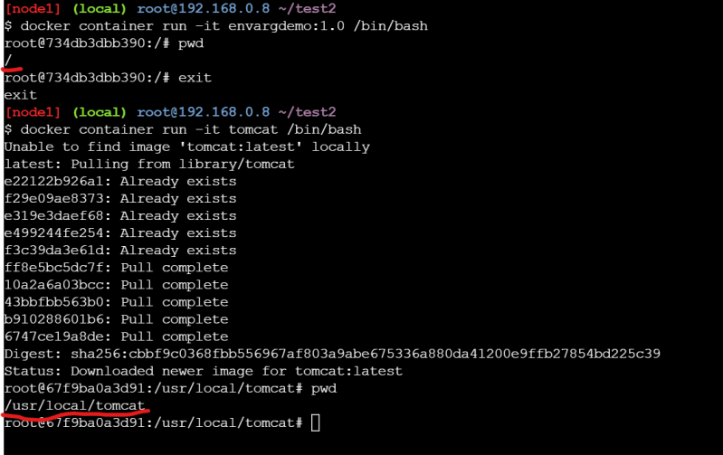
- By default if we donot specify the default working directory is /
- Where as in Dockerfile it is possible to change the working directory
- Ref:(https://github.com/asquarezone/DockerZone/commit/9d58075d9d97b8cade58197bf9c1fce026cb1ab5?branch=9d58075d9d97b8cade58197bf9c1fce026cb1ab5&diff=split)for the changeset 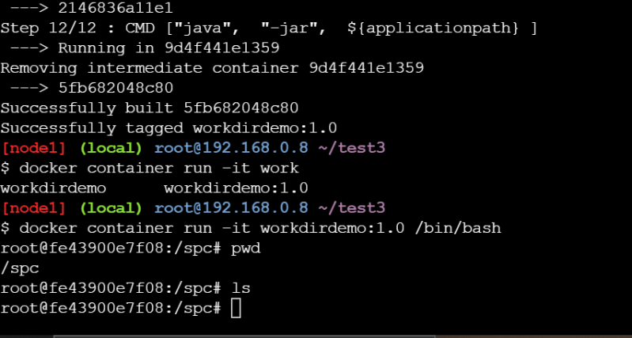

ADD and COPY instruction
During the docker image build process we might require to copy files from our local system into docker image filesystem. This can be acheived by using COPY/ADD instruction
COPY <source> <destination>
ADD <source> <destination>
- In some cases while building docker image you might require to download the files from some urls and copy to the docker file system, then we can use ADD instruction
ADD <source> <destination>
- Ref:(https://github.com/asquarezone/DockerZone/commit/957549fb0afa8c968ddb332bfaf0a982676ba484) and try to build the docker image and check the behavior of COPY and workdir

USER instruction
- Look at the example below 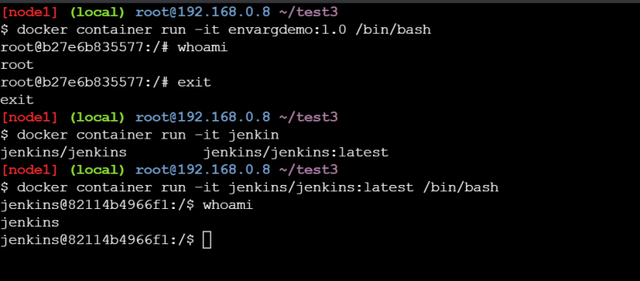
- So there is some way to set the default user other than root user in DockerImage. This can be achieved by using USER instruction

